**CMSC 433 Project 1 Global Documentation**

**Platform**

Our site is hosted un the UMBC GL web server on XXX account. As such, our technologies have certain limitations. Our website is using php 4 for interactions with the mySql database.

**Database**

The mySql database holds records referring to all of the classes available to the students. These were enter into the Courses table and do not change. Below is a picture showing the table and fields.

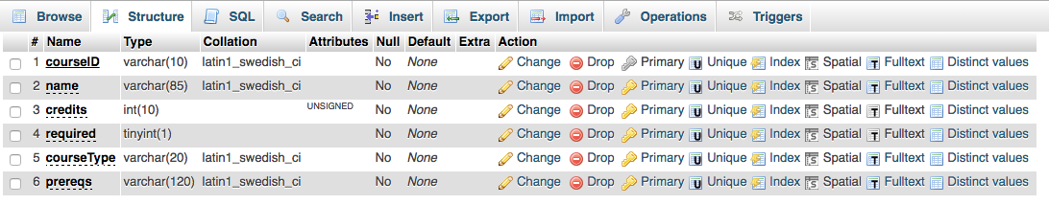

At the beginning login page, the user enters their personal information. This becomes a new record in the student table. If they are in the records, the app will notify the student to take further action to delete courses or view old options. The Students table is below.

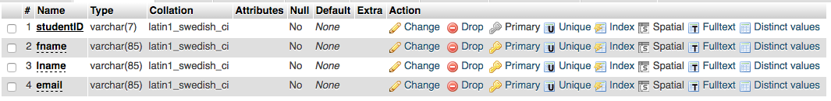

Next, the user must enter the classes that they have taken. This is represented in a foreign key constrained table. The table has two foreign keys, one for student and one for course. The table is below.



**Version Control**

Our team utilized a github account to share code amongst the team. This was useful because we could revert back to an older version if needed. The url is:

**Future Improvements**

Going forward we would like to include more error validation including preventing script injection and html sanitization of user inputs. We would also like to try and use the MVC model discussed in class. We feel that it would be really cool to build a tree as the website that allows students to select classes as well, instead of the checkbox selection that we currently have implemented.